Formalization of Stronger futures in Northern Territory Act 2012 (Division 3 subsection 41 and 42)

The formalization has been done using *Defeasible* rules and deontic modalities of obligation and permission. The section primarily focuses on obtaining a community store licence through the permission of the secretory (the process has many obligations and rules).

The process has been developed by the lines of *Modelling contracts using RuleML* [1].

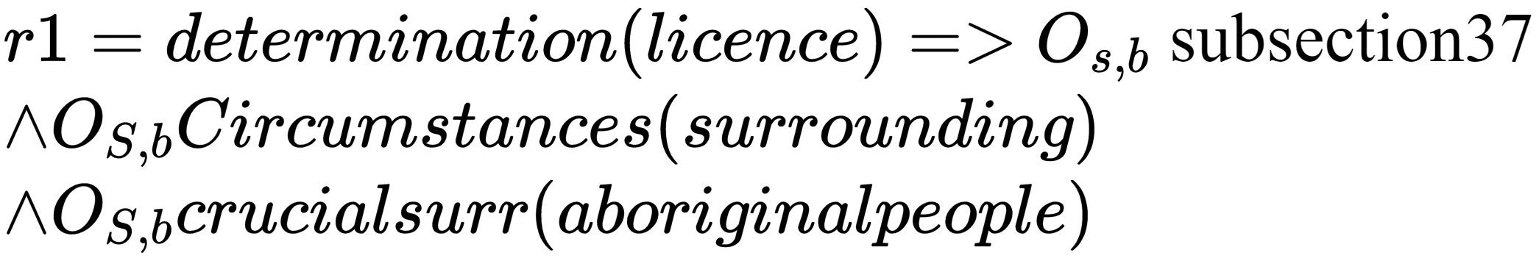

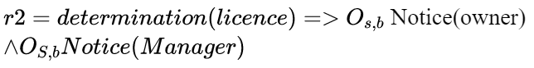

**(r2 > r1)** Superiority relation between two rules

Here states that A is obligatory such that s is the subject of the obligation and b is the beneficiary.

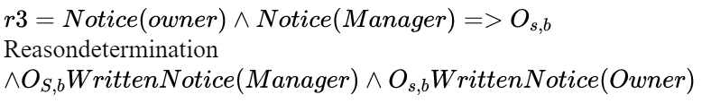

Similarly, the written notice from the manager and the owner must be done in specific time frame, unless the secretary has approved for longer period of duration.

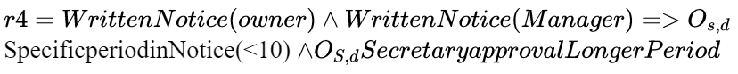

The superiority relation is as follows **(r1>r2>r3>r4)**. If there is no obligation followed in rule 1 then there will not be any further rules. In defeasible rules the rule superiority determines which rule has higher precedence on the other.

*¬circumstances(surroundings),* ¬*subsection37,* ¬*Notice(owner),* ¬*Notice(Manager),* ¬*WrittenNotice(Manger),* *¬WrittenNotice(Owner), ¬SpecificperiodinNotice(<10), ¬SecretaryapprovalLongerPeriod* ***=>*** *¬determination(licence)*  ------ rule(5)

Using the (r1,r2,r3,r4) and r5 we deduce according to this deduction step 

***determination(licence),Notice(owner),Notice(Manager),WrittenNotice(owner),WrittenNotice(manager****)*